Unit-3

**Class and Object**

**Class:** Class is a fundamental concept of object-oriented programming (OOP). A class is a group of objects which have common properties. It is a template or blueprint from which objects are created.

A class in Java can contain:

* **Declarations**
  + A class is declared using the class keyword followed by the class name. For example:  
    public class Student  
      {  
        //Data Member  
        //Member Function  
      }

* **Fields**
  + Fields can be of any data type, including primitive types, reference types, or other classes. Example. int a,b;
* **Methods**
  + Classes contain methods, which represent the behavior of the class.
  + Example:   
    public void Add(int x, int b)

    {

    }

* **Constructors**
  + Constructors are special methods used for initializing objects.

  public class Student

  {

    public Student()

    {

    }

  }

* **Access Modifier**
  + Classes, fields, and methods can have access modifiers such as **public**, **private**, **protected**, or **package-private (default).**
* **Class Body:** class body is surrounded by {}

General Form of Class:

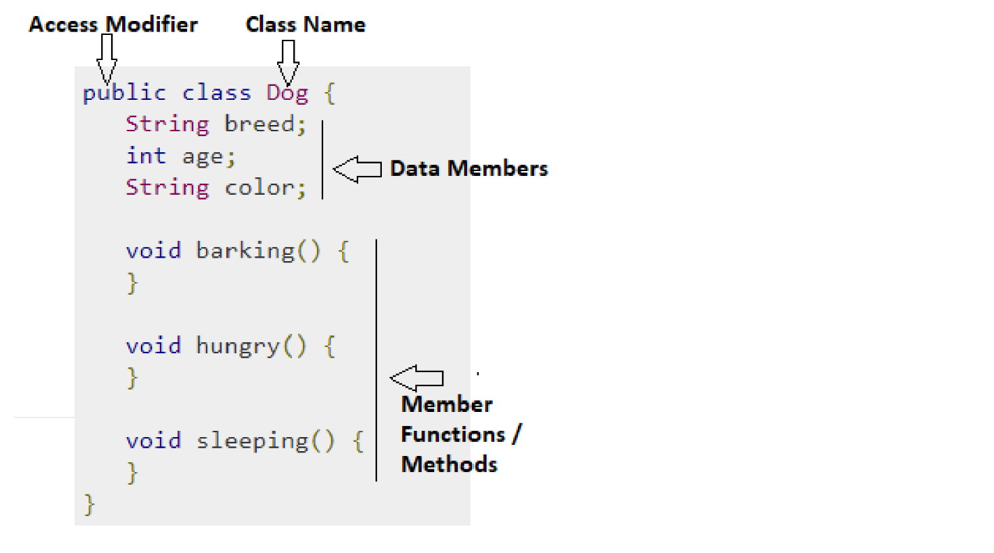

**Object**: An entity that has **state** and **behavior** is known as an **object**.

An object has three characteristics:

* **State:** represents the data (value) of an object.
* **Behavior:** represents the behavior (functionality) of an object such as deposit, withdraw, etc.
* **Identity:** An object identity is typ
* **#**ically implemented via a unique ID. The value of the ID is not visible to the external user. However, it is used internally by the JVM to identify each object uniquely.

**For Example**, Pen is an object. Its name is Reynolds; **color is white**, known as its **state**. It is **used to write**, so writing is its **behavior**.

There are three steps when creating an object from a class −

* **Declaration** − A variable declaration with a variable name with an object type.
* **Instantiation** − The 'new' keyword is used to create the object.
* **Initialization** − The 'new' keyword is followed by a call to a constructor. This call initializes the new object.

**Syntax:**

Student st=new Student();

Below Example shows implementation of Class and Object

public class App {

    public static void main(String[] args) throws Exception {

      Student st=new Student();

      st.DisplayName();

     }

  }

  class Student

  {

   public void DisplayName()

   {

    System.out.println("Sunil Chaudhary");

   }

  }

|  |  |
| --- | --- |
| **Abstraction** | **Encapsulation** |
| Abstraction is a general concept formed by extracting common features from specific example or The act of withdrawing or removing something **unnecessary** | Encapsulation is the mechanism that binds together code and the data it manipulates, and keeps both **safe from outside interference** and **misuse** |
| You can use abstraction using **Interface** and **Abstract** class | You can implement encapsulation using **Access Modifiers**(public, protected and private) |
| Abstraction solves the problem in **Design** level | Encapsulation solves the problem in **Implementation** level |
| Hiding implementation using abstract class and interface | Encapsulation hiding data using getters and setters |

**Abstraction is a process of hiding the implementation details and showing only functionality to the user.**

Abstraction means to show **What** part of functionality.

**For example,** if you have a class representing a car, the user of that class might only need to know how to **start** the car, **stop** the car, and perhaps how to **accelerate** and **brake**. They don't need to know the details of how the engine works or how the transmission shifts gears.

**This is typically achieved using abstract classes and interfaces.**

**Using Abstract Class:**

public class App {

    public static void main(String[] args) throws Exception {

        Circle c = new Circle();

        c.draw(); // Output: Drawing Circle

     }

  }

abstract class Shape {

    abstract void draw(); // Abstract method

}

class Circle extends Shape {

    void draw() {

        System.out.println("Drawing Circle");

    }

}

class Rectangle extends Shape {

    void draw() {

        System.out.println("Drawing Rectangle");

    }

}

**Using Interface**

public class App {

    public static void main(String[] args) throws Exception {

        Circle circle = new Circle();

        circle.draw(); // Output: Drawing Circle

     }

  }

interface Drawable {

    void draw();

}

class Circle implements Drawable {

    public void draw() {

        System.out.println("Drawing Circle");

    }

}

class Rectangle implements Drawable {

    public void draw() {

        System.out.println("Drawing Rectangle");

    }

}

**Encapsulation:** **Encapsulation** is one of the fundamental concepts of Object Oriented Programming (OOP) paradigm. It is the process of wrapping the data stored in the member variables of a class with its member functions.

It is done in such a way that the data is hidden to everything outside the class scope, and can only be accessed and modified through its own member functions.

**How to achieve Encapsulation:**

* Declaring the class variables as **private** so that they are inaccessible from outside the scope of the class.
* Designing **getter** and **setter** methods for the class and using them accordingly.

**Why do we need Encapsulation:**

* It helps you in achieving loose coupling.
* Encapsulation makes the application simple and easy to debug.
* Allows the programmer to control the data accessibility of a class.

**Advantages of Encapsulation:**

* Cleaner, more organized and less complex code.
* More flexible code as can modify a unit independently without changing any other unit.
* Makes the code more secure.
* The code can be maintained at any point without breaking the classes that use the code.

LAB: Write a java program to achieve encapsulation using private access modifier.

**Example: using private access modifier**

public class App {

    private int length;

    private int breadth;

    public App(int l, int b)

    {

        this.length=l;

        this.breadth=b;

    }

    public void Area()

    {

        System.out.println(length*breadth);

    }

    public static void main(String[] args) throws Exception {

        App ap=new App(2,3);

        ap.Area();

    }

}

Output:6

LAB: Write a java program to achieve encapsulation using getter and setter.

**Example:** using **getter** and **setter**

public class App {

    private String author;

    private String title;

    public String getAuthor() {

        return author;

      }

      public void setAuthor(String a) {

        this.author = a;

      }

      public String getTitle() {

        return title;

      }

      public void setTitle(String t) {

        this.title = t;

      }

    public static void main(String[] args) throws Exception {

       App a=new App();

       a.setAuthor("Sunil Chaudhary");

       a.setTitle("MR.");

       System.out.println(a.getTitle()+" "+a.getAuthor());

    }

}

Example:

public class App {

    public static void main(String[] args) throws Exception {

      Rectangle rect=new Rectangle();

      rect.setLength(5);

        rect.setBreadth(5);

        System.out.println(rect.getLength()*rect.getBreadth());

     }

  }

  class Rectangle

  {

    private int length;

    private int breadth;

    public int getLength() {

      return length;

    }

    public void setLength(int length) {

      this.length = length;

    }

    public int getBreadth() {

      return breadth;

    }

    public void setBreadth(int breadth) {

      this.breadth = breadth;

    }

  }

**Output: MR. Sunil Chaudhary**

**Constructor:**

A constructor is a block of codes similar to the method. It is called when an instance of the [class](https://www.javatpoint.com/object-and-class-in-java) is created.   
Constructor name must be the same as its class name  
A Constructor must have no explicit return type

There are three types of constructor in java.

* Default Constructor
* No-Args constructor
* Parameterized constructor

**Default Constructor:**

If we do not create any constructor, the Java compiler automatically creates a no-arg constructor during the execution of the program.

This constructor is called the default constructor.

public class App {

    int a;

    boolean b;

    public static void main(String[] args) throws Exception {

        App ap=new App();

        System.out.println(ap.a);

        System.out.println(ap.b);

     }

  }

**No-Args Constructor:**

constructor may or may not have any parameters (arguments).

If a constructor does not accept any parameters, it is known as a no-argument

public class App {

    public static void main(String[] args) throws Exception {

        Rectangle rect=new Rectangle();

        rect.Add();

     }

  }

  class Rectangle

  {

    int a=0;

    int b=0;

    public Rectangle()

    {

        a=5;

        b=6;

    }

    public void Add()

    {

        System.out.println(a+b);

    }

  }

**Parameterized Constructor:**

A Java constructor can also accept one or more parameters. Such constructors are known as parameterized constructors.

public class App {

    public static void main(String[] args) throws Exception {

        Rectangle rect=new Rectangle(5,6);

        rect.Add();

     }

  }

  class Rectangle

  {

    int first=0;

    int second=0;

    public Rectangle(int x, int y)

    {

        first=x;

        second=y;

    }

    public void Add()

    {

        System.out.println(first+second);

    }

  }

**“this” keyword**

* It can be used to call current class methods and fields, to pass an instance of the current class as a parameter,
* To differentiate between the local variable (variable that is declared inside the body of a method) and instance variables (variable is defined without the STATIC keyword, but as outside of a method declaration).
* To Invoke Default Constructor
* Using “this” reference can improve code readability and reduce naming conflicts.
* To Invoking **method** of **Current Class**

**Lab.Write a java program to demonstrate “this” keyword**

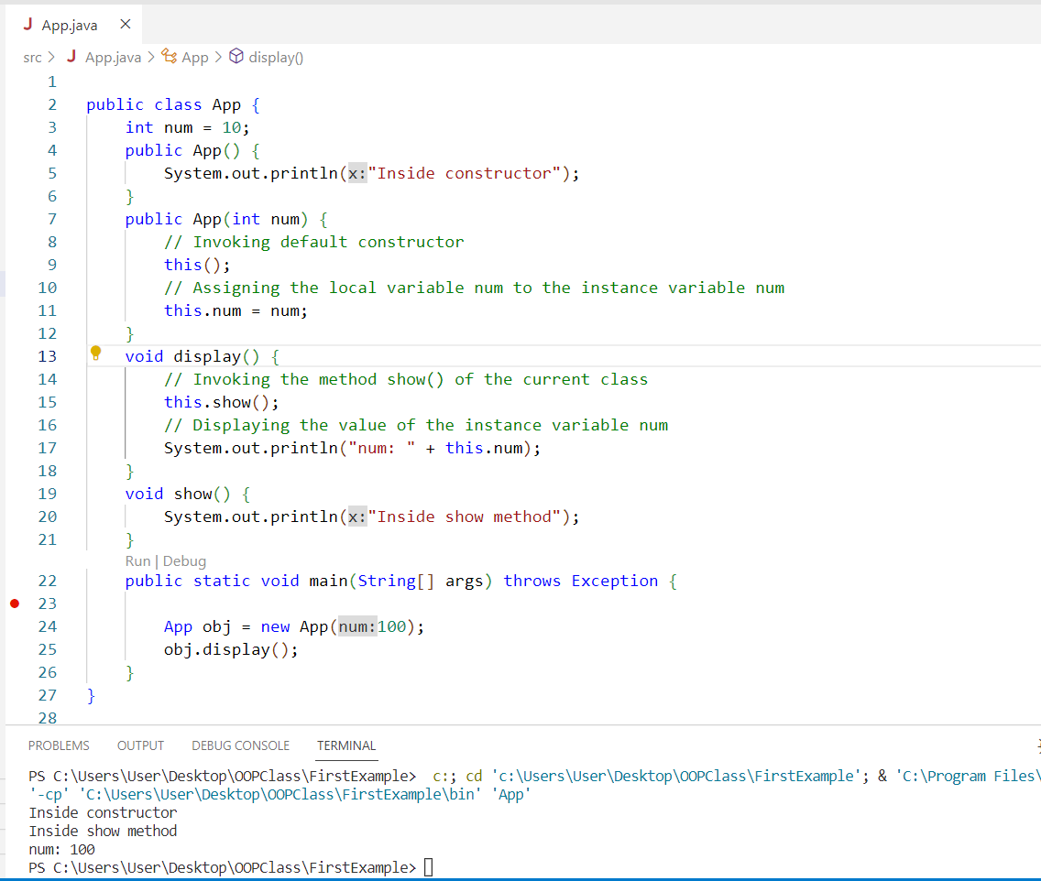

**Inner Class (Nested Class):**

In Java, just like methods, **variables of a class** too can have **another class as its member**. Writing a class within another is allowed in Java. The class written within is called the **nested class**, and the class that holds the **inner class** is called the **outer class**.

**There are certain advantages associated with inner classes are as follows:**

* Making code clean and readable.
* **Private methods** of the outer class can be accessed, so bringing a new dimension and making it closer to the real world.
* Optimizing the code module.

Syntax:

//outer  
class Java_Outer_class

    {

        //Inner Class

        class Java_Inner_class

        {

         //code

        }

    }

**Types of Inner Class**

1. Local Inner Classes
2. Anonymous Inner Classes
3. Static Inner Classes

**Local Inner Class:** declared class inside class

public class App {

    public static void main(String[] args) throws Exception {

        Outer.Inner in = new Outer().new Inner();

        in.show();

    }

}

// Class 1

class Outer {

    // Class 2

    // Simple nested inner class

    class Inner {

        // show() method of inner class

        public void show()

        {

            // Print statement

            System.out.println("In a nested class method");

        }

    }

}

**Anonymous Inner Class:** An anonymous inner class can be useful when making an instance of an object with certain "extras" such as overloading methods of a class or interface,

 Java Anonymous inner class can be created in two ways:

1. Class (may be abstract or concrete).
2. Interface

**Example Using Abstract Class**

abstract class Utilities{

    abstract void display();

  }

public class App {

      public static void main(String[] args)

      {

        Utilities p=new Utilities()

        {

            void display()

            {

                System.out.println("Good Morning");

            }

        };

            p.display();

      }

}

**Example Using Interface**

interface Utilities{

   public void display();

  }

public class App {

      public static void main(String[] args)

      {

        Utilities p=new Utilities()

        {

           public void display()

            {

                System.out.println("Good Morning");

            }

        };

            p.display();

      }

}

**Static Inner Class:** Static nested classes are not technically inner classes. They are like a static member of outer class.

public class App {

    public static void main(String[] args) throws Exception {

        Outer.Inner.display();

    }

}

// Class 1

// Outer class

class Outer {

      // Class 2

    // Static inner class

    static class Inner {

        public static void display()

        {

            // Print statement

            System.out.println("inside inner class Method");

            // Calling method inside main() method

        }

    }

}

## Method (Pass by Value and Pass By Reference)

## When a primitive type is passed to a method ,it is done by use of call-by-value . Objects are implicitly passed by use of call-by-reference

## Pass by Value in Java passing the parameters by values does not affect the original variable.

## Here we have initialized a variable ‘a’ with some value and used the pass-by-value technique to show how the value of the variable remains unchanged.

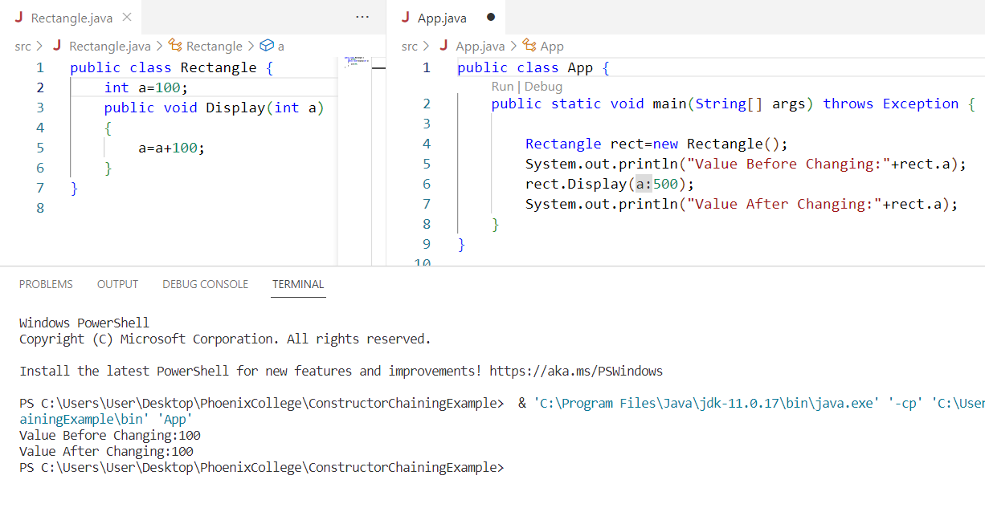

## Pass by Reference in Java

As you can see, when we have passed the **object reference** as a value instead of a value, the original value of the variable ‘a’ is changed to 200. This is because of the changes in the called

method.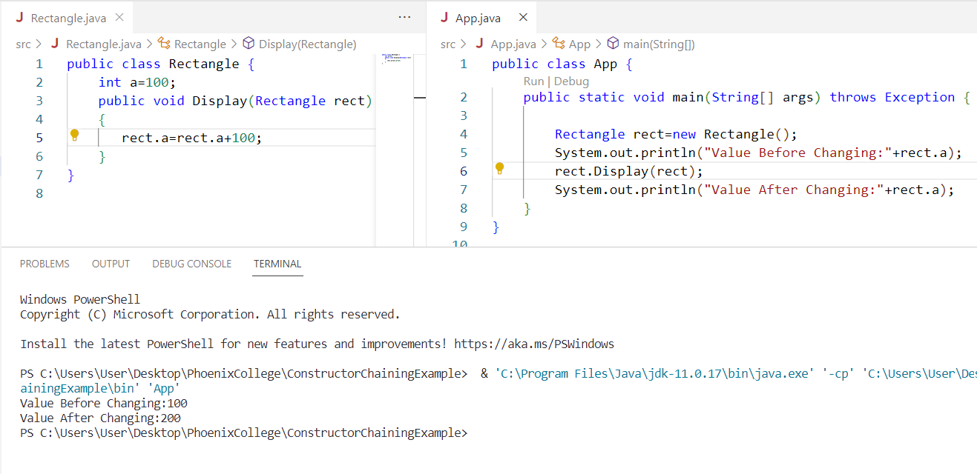

## Access Modifiers Access modifiers specify the availability of a parent class. In real-time coding, we cannot allow child classes to have access to all of the other classes. The availability of a data member, method, or constructor can be described in four ways.

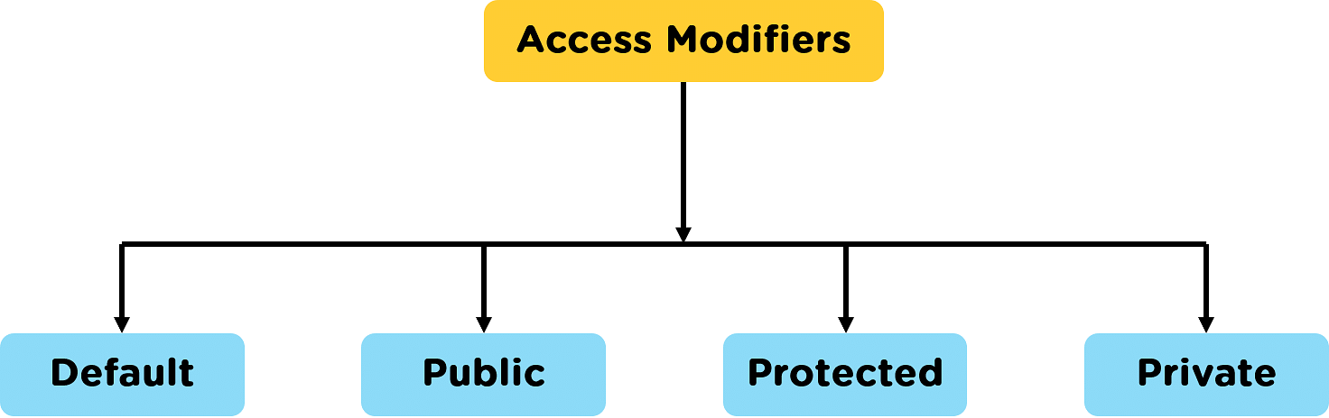

|  |  |
| --- | --- |
| Modifier | Description |
| Default | declarations are visible only within the package (package private) |
| Private | declarations are visible within the class only(data member,Function Member) |
| Protected | declarations are visible within the package or all subclasses  (data member,Function Member) |
| Public | declarations are visible everywhere |

**Default Access Modifier:**

package defaultPackage;

class Logger {

void message(){

System.out.println("This is a message");

}

}

Here, the **Logger** class has the **default** access modifier. And the class is visible to all the classes that belong to the **defaultPackage** package. However, if we try to use the **Logger** class in another class outside of **defaultPackage**, we will get a compilation error.

**Private Access Modifier**  
When **variables** and **methods** are declared **private**, they cannot be accessed outside of the class. For example,

class Data {

// private variable

private String name;

}

public class Main {

public static void main(String[] main){

// create an object of Data

Data d = new Data();

// access private variable and field from another class

d.name = "Programiz";

}

}

In the above example, we have declared a **private** variable named name. When we run the program, we will get the following error:  
The error is generated because we are trying to access the **private** variable of the Data class from the **Main class**. In this case, we can use the **getters** and **setters** method. For example,

class Data {

private String name;

// getter method

public String getName() {

return this.name;

}

// setter method

public void setName(String name) {

this.name= name;

}

}

public class Main {

public static void main(String[] main){

Data d = new Data();

// access the private variable using the getter and setter

d.setName("Programiz");

System.out.println(d.getName());

}

}

**Protected Access Modifier**  
When **methods** and **data** members are declared **protected**, we can access them within the same **package** as well as from **subclasses**. For example,

class Animal {

// protected method

protected void display() {

System.out.println("I am an animal");

}

}

class Dog extends Animal {

public static void main(String[] args) {

// create an object of Dog class

Dog dog = new Dog();

// access protected method

dog.display();

}

}

**Public Access Modifier**  
When **methods**, **variables**, **classes**, and so on are declared **public**, then we can access them from anywhere. The public access modifier has no scope **restriction**. For example,

// Animal.java file

// public class

public class Animal {

// public variable

public int legCount;

// public method

public void display() {

System.out.println("I am an animal.");

System.out.println("I have " + legCount + " legs.");

}

}

// Main.java

public class Main {

public static void main( String[] args ) {

// accessing the public class

Animal animal = new Animal();

// accessing the public variable

animal.legCount = 4;

// accessing the public method

animal.display();

}

}

**Polymorphism:**

**Polymorphism in Java** is a concept by which we can perform a *single action in different ways*(one name multiple forms). Polymorphism is derived from 2 Greek words: **poly** and **morphs**. The word "poly" means **many** and "morphs" means **forms**. So polymorphism means many forms.

There are two types of polymorphism in Java:

* compile-time polymorphism(method overloading)
* runtime polymorphism. (Method Overriding)

**Method Overloading:**

public class App {

    public static void main(String[] args) throws Exception {

      Calculator cal=new Calculator();

      System.out.println(cal.add(2, 3));

      System.out.println(cal.add(4, 5, 6));

     }

  }

  class Calculator {

    // Method to add two integers

    public int add(int a, int b) {

        return a + b;

    }

    // Method to add three integers

    public int add(int a, int b, int c)

    {

        return a + b + c;

    }

}

Method Overriding:

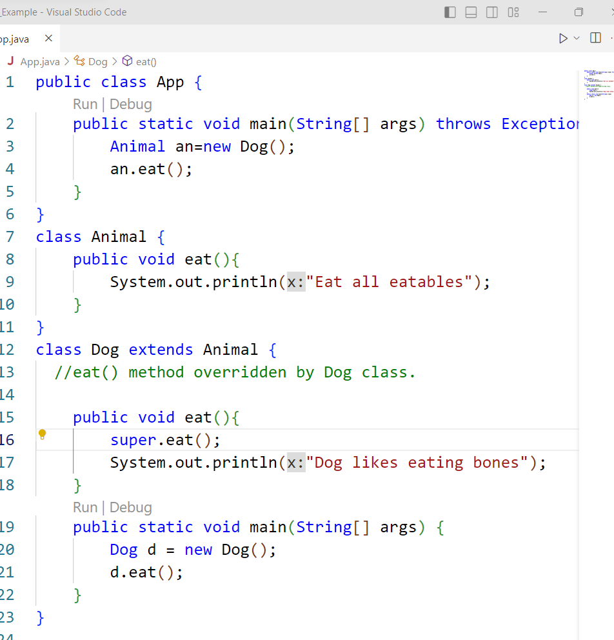

**Why do we need abstract class?Explain with real life example**.

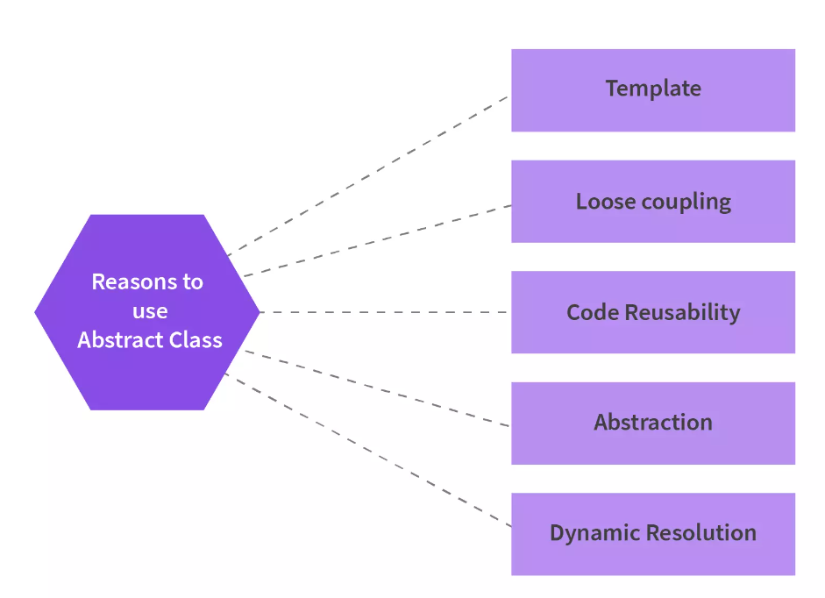

**Template Programming***Abstract classes provide a blueprint to be followed by the classes that extend the Abstract class.* Abstract Class because it gives a predefined template for any future specific class that you might need.

**Loose Coupling**To create a loosely coupled structure, abstract classes can be used.   
There are various benefits of Loose Coupling:  
*1. Easy maintenance of the code. Changes can be made to one class without affecting other classes.  
2. Testing of loosely coupled structures is easier as we can divide the project into small modules and perform unit testing.*

**Code Reusability**Using an abstract class in an application saves time. We can declare an abstract method in the abstract class and call it from anywhere required. Abstract classes eliminate the need to repeatedly write the same code.  
**Abstraction**Data abstraction in Java helps the developers hide the actual method implementation from the end user and display only the method names . Abstract classes in Java help implement the concept of Abstraction.  
**Dynamic Method Resolution or Dynamic Method Dispatch**The Abstract Classes enable us with dynamic method resolution or the dynamic method dispatch process. The dynamic Method Resolution is a procedure where, at runtime, the calling of an overridden method is resolved.

### **Final Class in Java**

* The final class is a class that is declared with the **final keyword**.
* We can restrict class inheritance by making use of the final class.
* Final classes cannot be extended or inherited.
* If we try to inherit a final class, then the compiler throws an error during compilation.
* We can simply define a final class using the final keyword and can write the class body code according to our needs.
* As the final class is immutable and can't be inherited, it has some advantages such as **immutability**(unchangagle) and **security**.
* We can only create a final class if it is complete in nature, which means **it cannot be an abstract class**. All wrapper classes in Java are final classes, such as **String**, **Integer**, etc.

      final class BaseClass {

        // methods and variables of the base class

      }

      class ChildClass extends BaseClass {

        // COMPILE- TIME error as it extends final class

      }